
Vinayaka Nagar, Old Mahabalipuram Road, Paiyanoor, Kancheepuram Dist, Chennai- 603
Department of Physical Education Sports Activities Report
S.No | AVIT Team Position | Organized Intuition | Achievements Photos
1 | Football (Men) – Runner up | Mohamed Sathak Trophy - 2018  State Level Inter College Football Tournament held at Mohamed Sathak A.J. College of Engineering on 20th & 21st March 2018 | 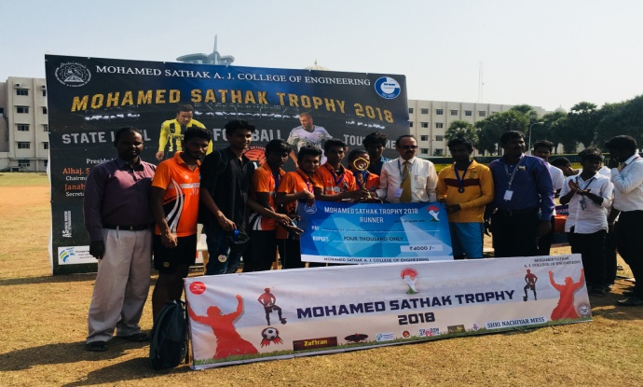  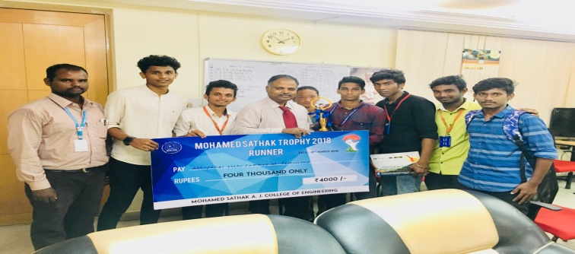
2 | The Following Sports and Games are conducted the AVIT Faculty Tournament – 2018.  Men  Tennis Ball Cricket  Screen Throw ball  Badminton  4 x 400 Relay  Carrom  Tug of War  Women  Throwball  Badminton (shuttlecock)  Carrom  4 x 100 Relay | AVIT Faculty Tournament – 2018  Organized by Department of Physical Education held at 11th and 12th January 2018, AV Campus. | 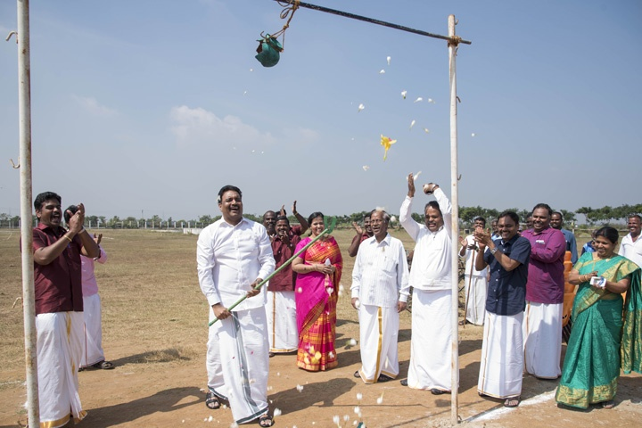  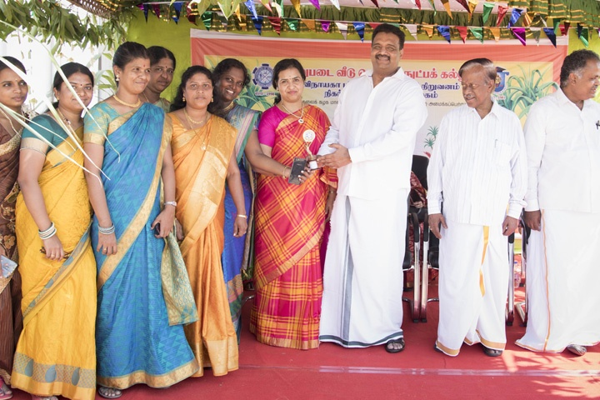  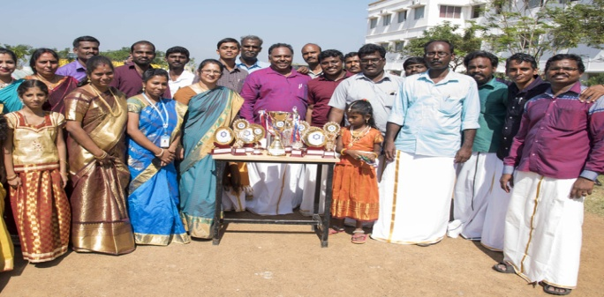  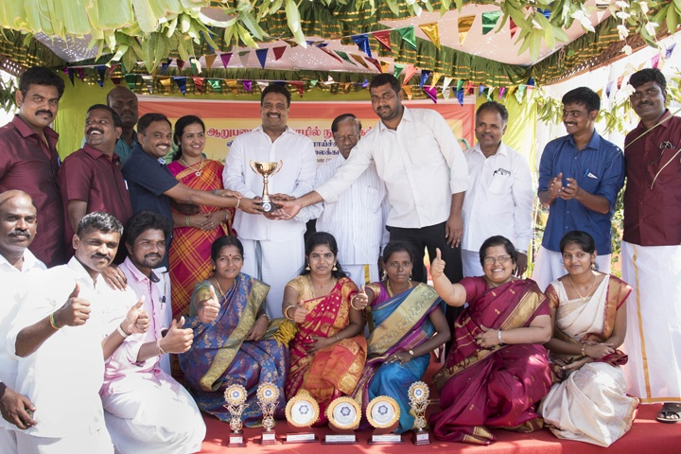
3 | Volleyball (Women) – Runner up | VIT Trophy – 2018  National Level Sports Festival held at VIT, Chennai on 29th January – 7th February – 2018. | 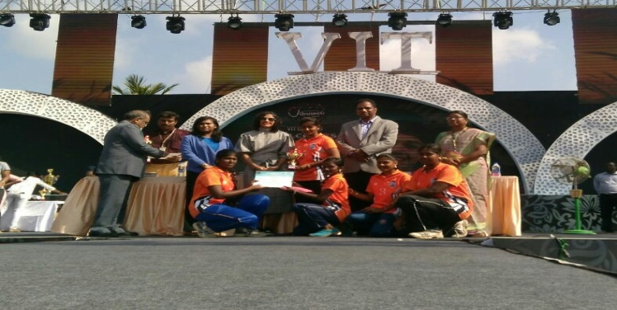
4 | Ball Badmitton (Men) - Winner | VMRF ICT  Vinayaka Mission’s Research  Foundation Intercollegiate Tournament held at Vinayaka Mission’s College of Physical Education , Salem on 04.10.2017 & 05.10.2017 | 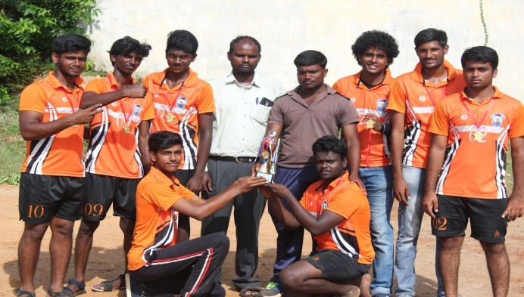  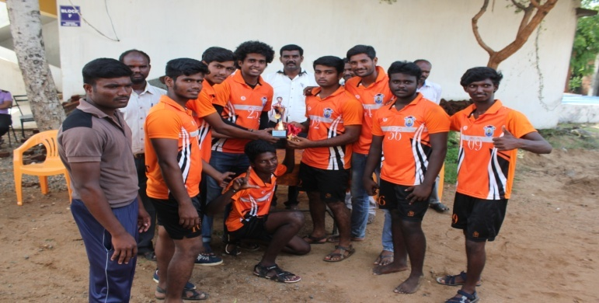
5 | Handball (Men) – Runner up | VMRF ICT  Vinayaka Mission’s Research  Foundation Intercollegiate Tournament held at Vinayaka Mission’s College of Physical Education , Salem on 04.10.2017 & 05.10.2017 | 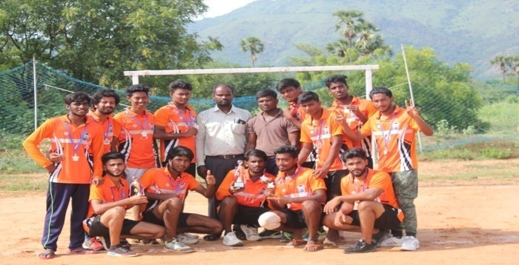  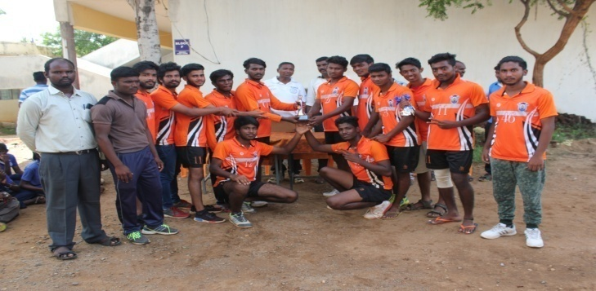
6 | Throwball (Women) – Runner up | VMRF ICT  Vinayaka Mission’s Research  Foundation Intercollegiate Tournament held at Vinayaka Mission’s College of Physical Education , Salem on 04.10.2017 & 05.10.2017 | 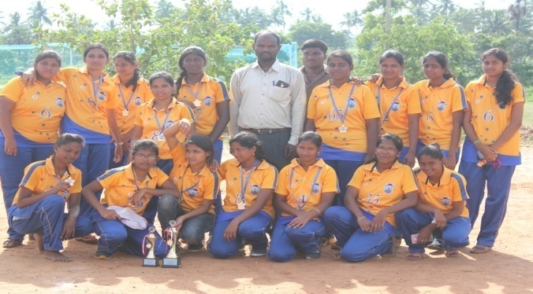  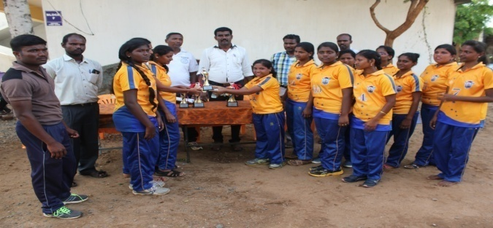
7 | Ball Badmitton (Women) – Runner up | VMRF ICT  Vinayaka Mission’s Research  Foundation Intercollegiate Tournament held at Vinayaka Mission’s College of Physical Education , Salem on 04.10.2017 & 05.10.2017 | 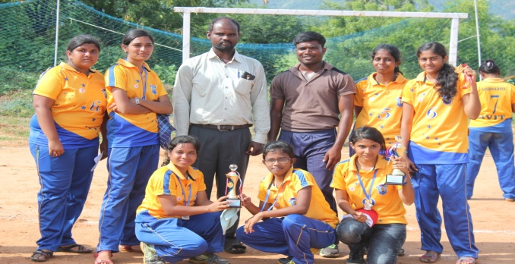  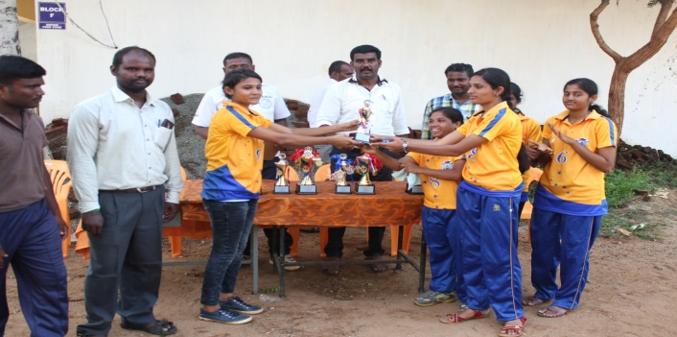
8 | Basketball (Men) – Runner up | VMRF ICT  Vinayaka Mission’s Research  Foundation Intercollegiate Tournament held at AVIT , Chennai on 11.10.2017 & 12.10.2017. | 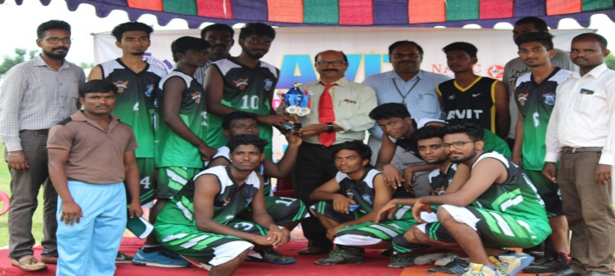
9 | Volleyball (Women) – Runner up | VMRF ICT  Vinayaka Mission’s Research  Foundation Intercollegiate Tournament held at AVIT , Chennai on 11.10.2017 & 12.10.2017. | 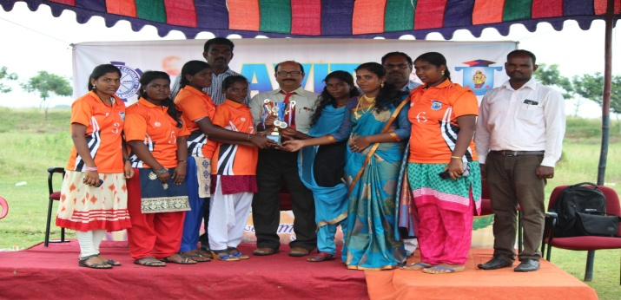
10 | 54 Players various Sports and Games were participated in South Zone and All India Inter University Tournament – 2017-18

